1.) Cut Index card into three equal sections…
**Prepare a flashcard for every stem on the current list.

**Flashcards must be prepared with effort. That means, neatly written.

**You must include at least one word but may use more in order to make a connection.

**Add the current list’s flashcards to the previous weeks’

2.) Side One: Stem and word Side Two: Definition
sub
submarine
under

3.) Hole punch card
sub
submarine

4.) Put card on ring
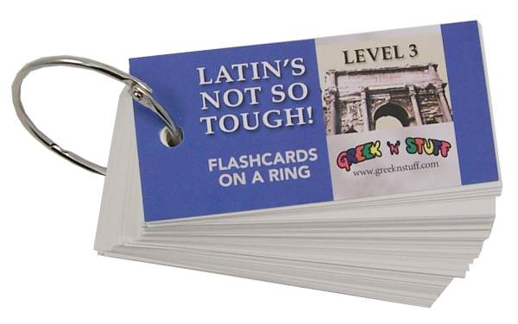
Student Name
Stem Vocabulary Flashcards

